# **CHAPTER 11**

**Q1. Existence is all that exists. What are the two types of realities that exist? Explain how you can distinguish these realities.**  
**Existence is whatever exists.**  
The essence of whatever exists is harmony or mutual fulfilment. The essence of whatever is/whatever is to be, is to be in harmony or mutual fulfilment. That is how the existence is.  
So, there are two types of basic realities in existence – one is space and the other is units. The units are in space. No matter where a unit is, or it is moved from one place to the other, it is always in space. There is no way a unit can be taken out of space. Units are inseparable from space, they are indivisible in space, they are submerged in space. These two realities always co-exist together.  
This is one basic difference between units and space. Space is unlimited and all-pervading whereas units are limited in size. Since units are limited in size, they can be counted in numbers, whereas space is unlimited. We can count five trees, eight people and so on, while we can only say the space, and not this space or that space as the space is all-pervading.

1. Units are Limited in Size; Space is Unlimited

We can observe units all around – they are limited in size. A unit may be

small or large, but it is limited in size. For example, a pencil is a unit which

is small in size. A human being is also a unit but it is relatively bigger in

size.

Now coming to space, it is unlimited. It is spread all around. It is

all-pervading. There is no limited size of space. We are not able to see its

boundary.

2. Units are Activity, they are Active; Space is “No-Activity”

Every unit is an activity and it is active. In itself, one or the other kind of

activity is always taking place in the unit. Further, the unit is interacting with

other units, i.e. it is active in relation to other units.

**Q2.** **Reason out why it is essential to study about space.**To be in harmony or to live in harmony, one needs to understand harmony at all these levels of being.  
So, there are two types of basic realities in existence – one is space and the other is units. The units are in space. No matter where a unit is, or it is moved from one place to the other, it is always in space. There is no way a unit can be taken out of space. Units are inseparable from space, they are indivisible in space, they are submerged in space. These two realities always co-exist together. Existence is in the form of co-existence which is in the form of units submerged in space.

**Q3. Units are in co-existence in space. Where there is a unit, space is also there. Explain these two statements.**  
When we say, units are submerged in the space, it means units are in space, they are inseparable from space. Where a unit is, space is also there. No matter where a unit is, or it is moved from one place to the other, it is always in space. There is no way a unit can be taken out of the space or separated from the space. **Existence is co-existence**. It is in the form of units submerged in space.  
Submergence implies three things:   
1. Units are energized in space   
2. Units are self-organized in space   
3. Units recognize their relationship and fulfil it with every other unit in space

**Q4. Distinguish between units and space.**So, there are two types of basic realities in existence – one is space and the other is units. The units are in space. No matter where a unit is, or it is moved from one place to the other, it is always in space. There is no way a unit can be taken out of space. Units are inseparable from space, they are indivisible in space, they are submerged in space. These two realities always co-exist together.  
There is one basic difference between units and space. Space is unlimited and all-pervading whereas units are limited in size. Since units are limited in size, they can be counted in numbers, whereas space is unlimited. We can count five trees, eight people and so on, while we can only say the space, and not this space or that space as the space is all-pervading.

**Q5. What is meant by Submergence of units in space? What are the three defining aspects?**  
When we say, units are submerged in the space, it means units are in space, they are inseparable from space. Where a unit is, space is also there. No matter where a unit is, or it is moved from one place to the other, it is always in space. There is no way a unit can be taken out of the space or separated from the space.  
Submergence implies three things:   
**1. Units are energized in space:**Being in co-existence with space, every unit is energized. We can observe any atom. The atom is in space. It is submerged in space. The sub-atomic particles rotate around their own axis. Subatomic particles in the various orbits also revolve around the nucleus. These and other such activities are going on in the atom. It is energised being in co-existence with space. The activities of the Self are continuous and this continuity seems to be independent of the state of the Body. The Self is in space and it is energised being in co-existence with space. The Self is submerged in space and the Body is also submerged in space. **2. Units are self-organized in space:**Being in co-existence with space, every unit is self-organised. It is in a definite order. By being in a definite order, it exhibits a definite conduct – that is how one can identify or recognise and study that unit. We can observe an atom again. It is in a definite order – so many sub-atomic particles, all playing a definite role. The atom has a definite conduct. The atom is self-organised being in co-existence with space. It has a definite conduct. **3. Units recognize their relationship and fulfil it with every other unit in space:**Being in co-existence with space, every unit recognises its relationship with every other unit in space and fulfils that relationship. An atom is in co-existence with space. It is energized in space as many activities are going on in it. These activities are self-organized, are in order and the atom exhibits a definite conduct. It recognizes and fulfils its relationship with other atoms and forms molecules. These molecules are an expression of atoms being in co-existence.

**Q6. Draw a chart showing all the different categories of units of nature in space.**  
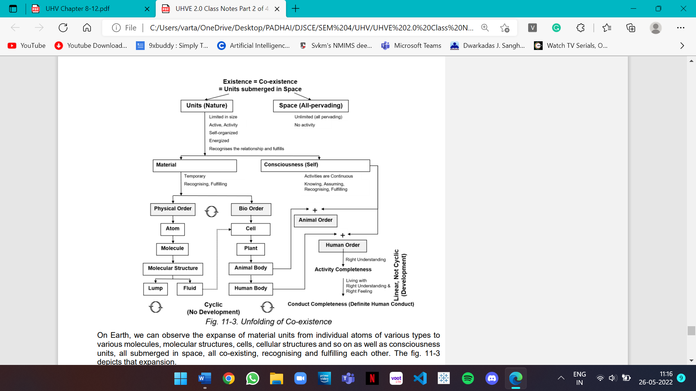

**Q7. In what types of units – material or consciousness, is there scope for development? Are we presently focusing on development in these types of units? Please elaborate.**  
Material units are temporary in time, while consciousness units (Self) seem to be continuous (as we saw that their needs and activities are continuous in time in contrast to the needs and activities of material units which are temporary in time).  
Material units recognise and fulfil their relationship – their conduct is definite. Consciousness units recognise and fulfil their relationship on the basis of assuming without knowing or assuming based on knowing – the conduct of the human being is definite if it is operating on the basis of assuming based on knowing, and it is indefinite if it is operating on the basis of assuming without knowing.  
Only in the human order, there is a potential for development or transformation in the Self which is not cyclic. Development or permanent change is possible only in the domain of consciousness. So far, there has been very minimal effort on this possibility, due to the prevailing notion that human being is body (material) and the existence is material in nature.

**Q8. What is the role of material order and bio-order in the fulfilment of human needs? How does understanding of existence help in right identification of the above?**  
In the physical-order, the smallest self-organised unit (in harmony) is the atom. Hydrogen, oxygen, iron and uranium are some examples. These atoms combine in a definite manner to form molecules. These molecules are also self-organised and exhibit definite conduct. There are hydrogen molecules, oxygen molecules, nitrogen molecules in the atmosphere. Similarly, there are innumerable molecules. Molecules, in turn, combine to make molecular structures.  
Coming to the bio-order, the smallest self-organised unit is the cell. In addition to the activity of formation-deformation, it has the activity of respiration. It is also recognising its relationship with every other unit in space and fulfilling it. Cells combine to form plants and trees. Cells combine to form tissues and organs, in turn, these combine to form the animal body and human body. That is the unfolding of the co-existence in the bio-order.  
The human order is also the co-existence of consciousness (Self) and the human body (material). There are many units in the human order. The Body may be black, brown, white, tall, short, fat, thin and so many variations. The Self is similar, so in that sense all human beings are of the same type. The human body has a definite recognition and fulfilment, while recognition and fulfilment of the Self is based on assuming with knowing or assuming without knowing, but with a will to live with continuous happiness. The ever-present co-existence is always at the base.

**Q9. How does co-existence in existence express itself at different levels of living of human being? Explain.**At the level of nature, this co-existence is expressed in the form of mutual fulfilment among all the units. Since the units are self-organized and recognise their relationship with other units in a mutually fulfilling manner; all the units put together are bound to be in harmony, i.e. nature, as a whole, is in harmony.  
At the level of society, the four human goals (happiness, prosperity, fearlessness and co-existence) are an expression of co-existence at various levels:   
• Happiness (right understanding, right feeling) is basically understanding co-existence, and ensuring the feeling and thought of co-existence at the level of the Self.   
• Prosperity is essentially an outcome of ensuring co-existence of human being with rest of the nature which results into prosperity of human being and preservation of the rest of the nature. Prosperity is a natural outcome of living in co-existence with rest of the nature by human being.   
• Fearlessness (trust) is ensuring the co-existence with other human beings at the level of family, society.   
• Co-existence is ensuring mutual fulfilment at the level of entire nature.  
At the level of the family, relationship is basically the expression of the co-existence of one human being with other human being. The nine feelings (trust, respect… love) are an expression of understanding and acceptance of co-existence in human-human relationship. Trust is the acceptance of the co-existence between one human being and another human being. Love is the acceptance of the co-existence of one human being with every human being and ultimately with every unit in existence. Justice is the realisation and fulfilment of co-existence of human being with other human beings.  
At the level of individual, human being is the co-existence of the Self and the Body.   
• Acceptance of co-existence in the Self for the Body is the feeling of self-regulation.   
• Expressing this feeling of co-existence between the Self and the Body leads to health at the level of body. Health also includes co-existence of all parts of the Body.   
• At the level of Self, our basic desire for continuity of happiness is ensured by realisation of co-existence, understanding of harmony in the nature, contemplation of participation in the larger order leading to the feeling of co-existence (love) and thought of co-existence (compassion).

**Q10. Describe the role of human being in this existence. What would be the natural outcome of fulfilling this role?**  
All that human being needs to do is to understand the co-existence and to live in co-existence:  
To understand co-existence:   
o To realise co-existence, i.e. to ensure it in the Self   
o To ensure the feeling and thought of co-existence, i.e. to ensure it in the Self   
The outcome of this step is happiness in the Self.  
To live in co-existence, to live with mutual fulfilment:   
o To live in co-existence with human being – from family to world family, leading to Undivided Society   
o To live in co-existence in entire nature – from family order to world family order, leading to Universal Human Order   
The outcome of this step is continuity of happiness for all, generation after generation.  
By understanding co-existence, we are referring to the Self-awakening to the activities of contemplation, understanding and realisation. Contemplation is about participation in the larger order, about relationship with every unit in existence; understanding is about the harmony in entire nature and realisation is of the existence as co-existence. All these together are called knowledge.